**Mid Ohio Valley Ghost Hunters**

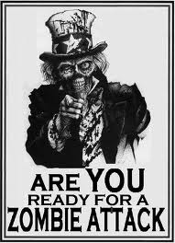

*Sept 1 – 4 – Washington County Fair*

*Sept 1 – 2 – Apple Butter Weekend on Blennerhassett Island*

*Sept 6 and 20 – Brunch with Margaret Blennerhassett*

*September 7 – 9 – Ohio River Sternwheel Festival*

*Sept 14 – Blennerhassett Island “Strings & Things”*

*Sept 14 -16 – Belleville Homecoming*

*Sept 15 – 16 – Harvest Moon Festival*

*Sept 28 – 30 – Volcano Days*

*Sept 28 – 30 – Barnesville Pumpkin Festival*

*Every Friday and Saturday 10 -4 – Mound Cemetery Tours*

James Moore has the date for the next Zombie Walk set.

The date for the next zombie invasion is October 13, 2012.

The site is Parkersburg City Park.

Watch for more details as the plans are completed.



***GROUP SPEAKING EVENTS***

*Nothing scheduled at this time.*



**PARA PHOTOS & VIDEOS**

If you haven’t done so, check out the pictures and videos that James Moore posted that were caught in the Anchorage. You can find them on his facebook page or on our group facebook page and on you tube. They will blow your mind.

**OTHER PARANORMAL ACTIVITIES**

**September 29 – Shocka-Con – Charleston,**

**Overnight hunts are available at the Anchorage for $35 per person with a minimum of 3 people and a maximum of 10 people. Contact Tom Moore to book your hunt.**

**PARANORMAL MOVIES**

The Possession – released August 31st

The Apparition – released August 24th

Paranormal Activity 3 – to be released October 19

Hollow – to be released October 19

Sinister – to be released October 5

Silent Hill – Revelation 3D – to be released October 26

**LOCAL PARANORMAL NEWS**

**PARKERSBURG ZOMBIE WALK**

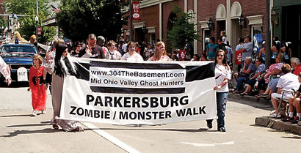

304 The Basement as well as some of the members of the Mid Ohio Valley Ghost Hunters entered the 2012 Parkersburg Homecoming Parade to help distribute flyers for the 2nd annual Parkersburg Zombie Walk. We even had several people cheering for us along the parade route. Fun was had by all who participated.

It was a very pleasant surprise to find out on Sunday, after the parade that our little group had placed 2nd in the Non-Commercial classification.

**THE DEAD FILES COMES TO PARKERSBURG**

Travel Channel television crews for the Dead Files were in Parkersburg filming for a future episode that may air in November.

There are some that say they were filming on Quincy Hill as well as on Fort Boreman.

**TWIN CITY OPERA HOUSE FEATURED ON BIOGRAPHY CHANNEL**

Eric Glosser and Brendan Shay of the United Paranormal Project was featured on the Biography Channel’s, My Ghost Story, Caught on Tape.

He told his stories and showed his evidence that he and his fellow ghost hunters collected while at the Twin City Opera House in McConnelsville, Ohio.

You can view the complete episode online.

**COMMUNITY NEWS**

Have you seen a paranormal movie lately? Would you be willing to write a review for the newsletter? If so, e-mail me or bring in a written review and I can add it to the newsletter.

The Washington County Historical Society holds their monthly meeting on the first Monday of every month in Marietta at St. Lukes Episcopal Church at 7:30 pm. They do have a yearly membership fee of $20. For more information their website is [www.wchs-ohio.org](http://www.wchs-ohio.org).

The Wood County Historical and Preservation Society holds their monthly meeting on the last Monday of every month in Parkersburg at the Parkersburg & Wood County Public Library at 7 pm. They do have a yearly membership fee of $15. For more information their website is [www.wchps.com](http://www.wchps.com).

Caption describing picture or graphic.

**HELP WANTED –** Do you have something you would like to see in our newsletter? I would love to keep the newsletter going and growing. I need your help. If you would like to add something to the newsletter, please e-mail it to me at [vlwohio@yahoo.com](mailto:vlwohio@yahoo.com). Any and all help will be greatly appreciated.

**ATTENTION**: *Do you have EVPs or experiences from a hunt you were on*? We are trying to keep track of things that happen on the hunts to watch for reoccurring events. Please get with someone with your story or EVPs so we can add them to our list. You will receive all credit for any EVPs, pictures and experiences.

**Something to think about –** Is there a difference between

a ghost and a spirit? What do you think?