JULY 2013 NEWSLETTER

GOT GHOSTS?

If you have or know of someone that needs help with unknown happenings in their home or business, just let us know.

We can schedule an investigation of the site and give you our determination of what may be happening.

We do not charge for our services.
ARE YOU READY FOR SUMMER

GROUP SPEAKING EVENTS

Nothing scheduled for July

Are you a member of an organization and would like someone from our group speak at your meeting, please contact us.

June’s monthly meeting review

At June’s meeting we had an attendance of 17 people.

Our meeting consisted of discussing upcoming investigations. We also discussed our most current past investigations and some of the experiences and EVPs that we caught on those investigations.

The main program for the evening was an open discussion on the many ways of protecting yourself while ghost hunting.

We announced that we will continue discussing protection during ghost hunting and options of protection as well as the possibilities of possession.

To end the meeting we had an open discussion and answered any questions.

PARA PHOTOS & VIDEOS

If you haven’t done so, check out the pictures and videos that James Moore posted that were caught in the Anchorage. You can find them on his facebook page or on our group facebook page and on you tube. They will blow your mind.

OTHER PARANORMAL ACTIVITIES

Overnight hunts are available at the Anchorage for $35 per person with a minimum of 5 people and a maximum of 10 people. There is a $50 non-refundable deposit due once the date of your private hunt is approved with the balance due no later than 2 weeks prior to the hunt. Contact Tom Moore to book your hunt or send us a message on Facebook.

HELP WANTED – Do you have something you would like to see in our newsletter? I would love to keep the newsletter going and growing, but I need your help. If you would like to add something to the newsletter, please e-mail it to me at valerie.movgh@gmail.com. Any and all help will be greatly appreciated.

ATTENTION: Do you have EVPs or experiences from a hunt you were on? We are trying to keep track of things that happen on the hunts to watch for reoccurring events. Please get with someone with your story or EVPs so we can add them to our list. You will receive all credit for any EVPs, pictures and experiences.

COMMUNITY NEWS

The Washington County Historical Society holds their monthly meeting on the first Monday of every month in Marietta at St. Lukes Episcopal Church at 7:30 pm. They do have a yearly membership fee of $20. For more information their website is www.wchs-ohio.org.

The Wood County Historical and Preservation Society holds their monthly meeting on the last Monday of every month in Parkersburg at the Parkersburg & Wood County Public Library at 7 pm. They do have a yearly membership fee of $15. For more information their website is www.wchps.com.

6/01/2013 - 8/31/2013 - Mound Cemetery Tours - www.thecastle.edu

7/04/2013 - 7/06/2013 - Mountain State Art & Craft Fair - www.msacf.com

7/12/2013 - 7/13/2013 -Marietta Riverfront Roar - www.mariettaohio.org

7/12/2013 - Riverside Artists Gallery Participates in Downtown Marietta's Merchants and Artist Walk

7/16/2013 - 7/20/2013 - West Virginia Interstate Fair & Exposition
http://www.wvinterstatefair.org

7/19/2013 - 7/20/2013 - Ohio Valley Mud Run -
10K Obstacle Course Mud Run, 5K walk/run Obstacle Course Mud Run, Youth Challenge - 100 Yard Mud Run with several small obstacles
Friday - Live band for campers and guests. Food and drinks available. Saturday - Post-run cook out and live music for all participants, plus on course music for that extra push!
7/19/2013 - 7/20/2013 - Sweet Corn Festival - http://info@mariettasweetcorn.com

7/20/2013 - Living History Program - http://mariettacastle.org

7/20/2013 - The Longest Raid of the Civil War www.capusmartiusmuseum.org

7/26/2013 - "Swing Is The Thing" – www.mareittacastle.org

7/27/2013 - Island Frolic with Evening Meal - http://www.blennerhassettislandstatepark.com

7/27/2013 – 7/28/13 – Harmar Days

PARANORMAL MOVIES

The Death of a Ghost Hunter – This movie has been suggested by Valerie Wright.

I watched this movie figuring it would be a lot like Paranormal Activity or something similar. Come to find out it is not. The story is of a ghost hunter that was offered money to investigate a family home with the assistance of two other people. I was pleasantly surprised by this movie and would suggest you watch it if you get a chance.

UPCOMING RELEASES

The Conjuring - This movie is based on paranormal investigators Ed and Lorraine Warren. They were the same investigators of the Amityville House.

To be released July 19, 2013

Have you seen a paranormal movie lately? Would you be willing to write a review for the newsletter? If so, e-mail me or bring in a written review and I can add it to the newsletter.

NEW AND RETURNING PARANORMAL TELEVISION SERIES

I am not aware of any new or returning series at this time.

Have you read a new book? Submit your review.
RECENT AND UPCOMING BOOK PARANORMAL BOOK RELEASES

To be released July 1, 2013. Based on the life of John Mitchell.

The newsletter will only be available on our Face book page and our webpage. Calendars will available at the monthly meetings as usual.

Have you seen a new paranormal television series? Please submit your review of the series.

PARANORMAL NEWS TIDBITS

A statue that was made as an offering to Osiris, the Egyptian god of death, that is in the Manchester Museum in England has suddenly started spinning inside its display case for no known reason.
A time-lapse video has been posted on the internet to show the movement of the statue.
Campbell Price, of the museum first noticed the movement after he had put the statue back in its original spot and found it moved again the next day.
It was believed by the Ancient Egyptians that if a mummy had been destroyed that a statue could be used by the spirit of that mummy.
Some believe it just a vibration on the glass causing the movement, but Mr. Price says that this statue has never moved before.

UPCOMING TRAINING – August 31, 2013

We have started the plans to hold an all day training session at the Anchorage that will include at least the following:

History of the Anchorage and its families
How to find the history of a site
How to review video and audio recordings from a site
A hunt to use the training received.

The cost will be $15 per person for the hunt if you attend the training sessions.

Watch for further details.

HUNT REVIEWS

EATON TUNNEL – JUNE 6, 2013

Had 5 people in attendance even though it looked like it was going to rain.

EATON TUNNEL – JUNE 7, 2013

Had 8 people in attendance.

THE ANCHORAGE – JUNE 8, 2013

Had 12 people in attendance.

FORT BOREMAN – JUNE 15, 2013

Had 30 people in attendance for the cookout and started with 30 people for the hunt and overnight stay. Everyone had left by 4 am.

SHAWNEE PARK – JUNE 21, 2013

Had 4 people in attendance for this new site. Hope to add it to our yearly calendar.

If you would like to purchase a copy of the CD of the pictures from the 3rd Annual Masquerade Ball, just let us know. They will be available shortly and will cost $5.00 each.

Group T-shirts $20 each (we must have a minimum of 12 orders to order printing)

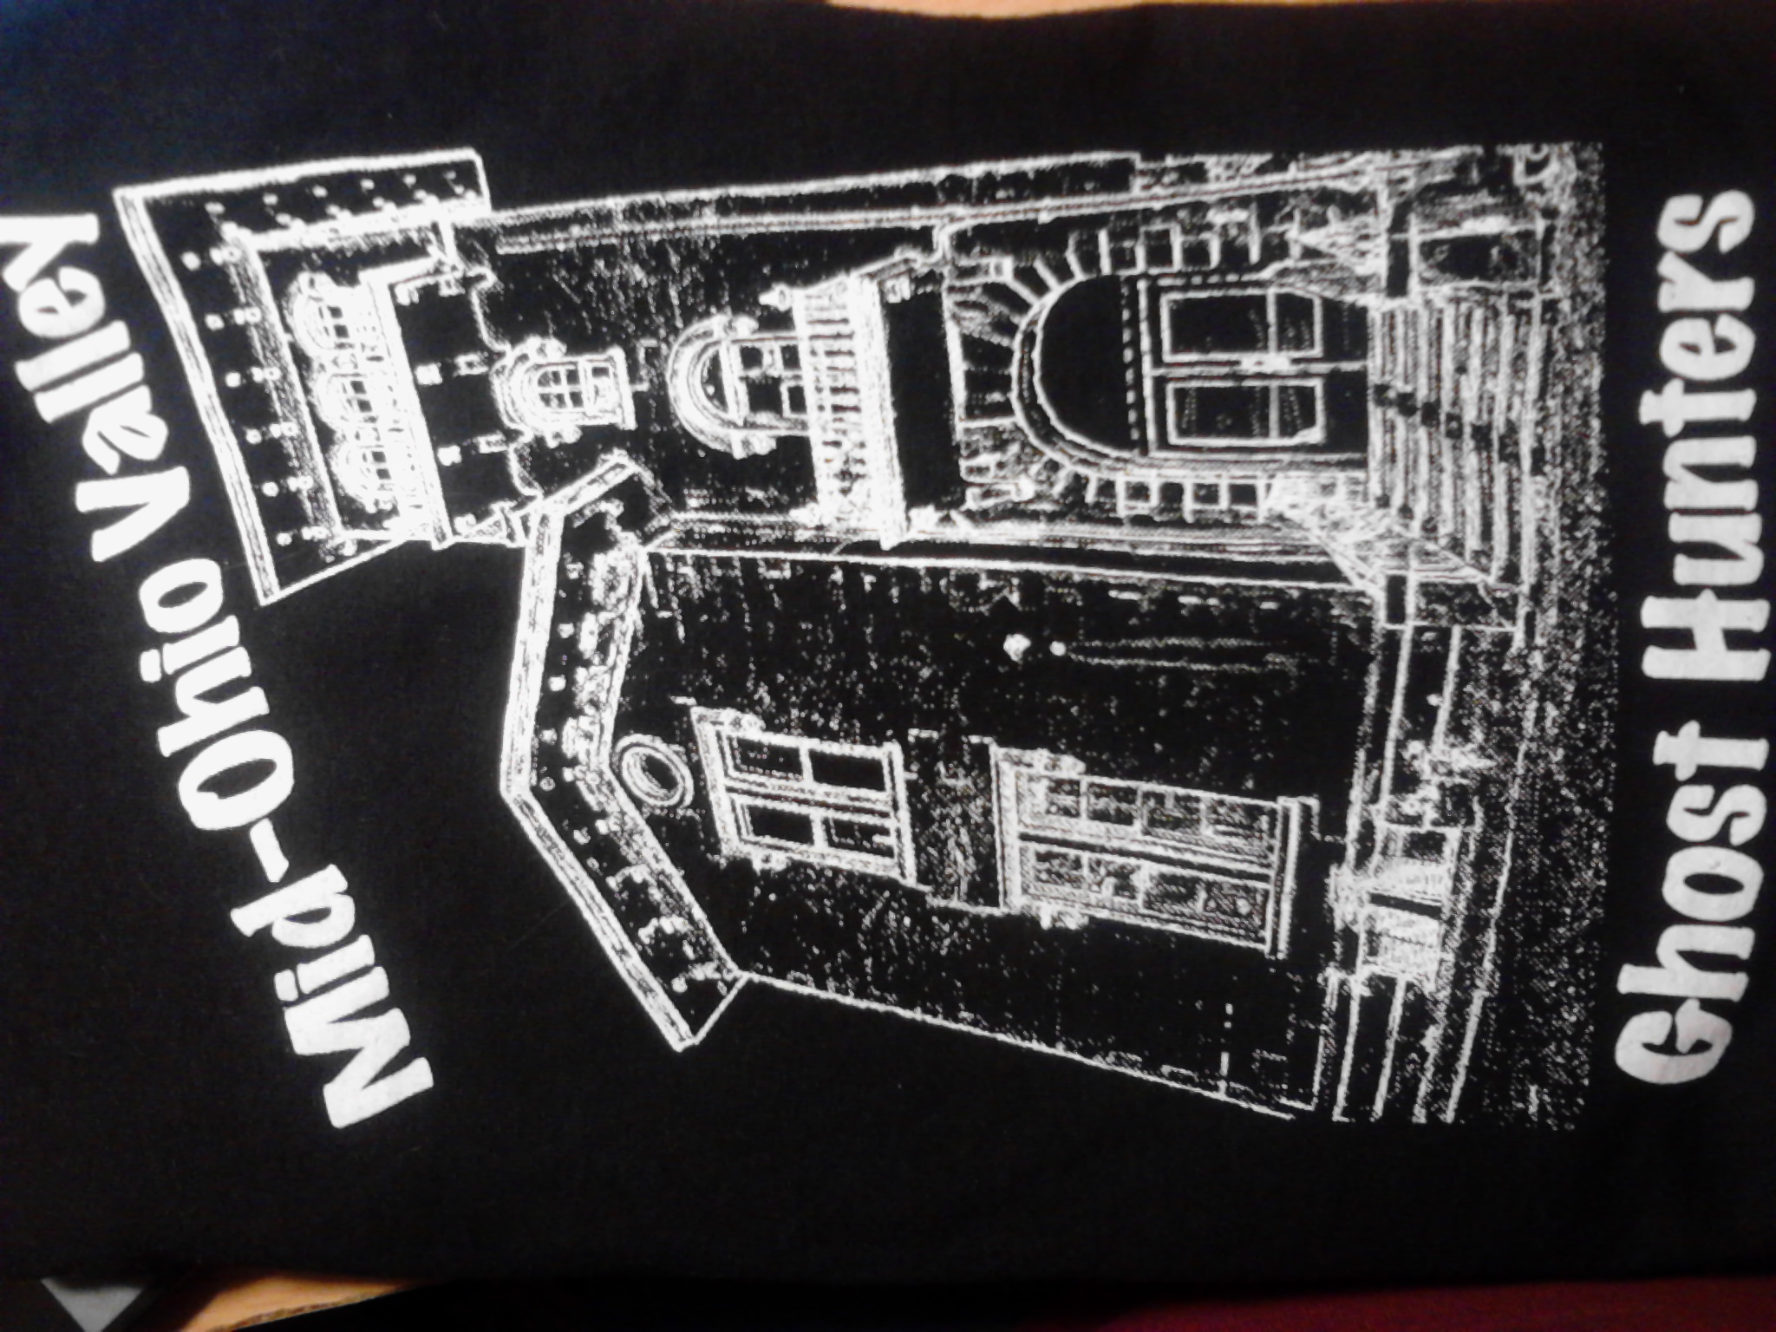

BULLETIN BOARD

